Vision Statement of the Department.
To be a preferred hub for nurturing computer engineering aspirants through innovative, ethical, value-based technical education, impactful research, and industry collaboration, to become successful professionals contributing for the betterment of society.
Mission Statement of the Department.
To nurture computer engineering professionals by offering Dynamic learning environment that encourages problem-solving using emerging technology, National Education Policy aligned evidence-based technical education, fostering ,innovation, research, and industry–institute collaboration & Holistic, ethical and sustainable development for lifelong success.

Session 2026-2027
Vision:Dream of where you want. | Mission: Means to achieve Vision
Program Educational Objectives of the program (PEO): (broad statements that describe the professional and career accomplishments)
PEO1 | Preparation | P: Preparation | Pep-CL abbreviation pronounce as Pep-si-lL easy to recall
PEO2 | Core Competence | E: Environment  (Learning Environment) | Pep-CL abbreviation pronounce as Pep-si-lL easy to recall
PEO3 | Breadth | P: Professionalism | Pep-CL abbreviation pronounce as Pep-si-lL easy to recall
PEO4 | Professionalism | C: Core Competence | Pep-CL abbreviation pronounce as Pep-si-lL easy to recall
PEO5 | Learning  Environment | L: Breadth (Learning in diverse areas) | Pep-CL abbreviation pronounce as Pep-si-lL easy to recall
Program Outcomes (PO): (statements that describe what a student should be able to do and know by the end of a program)
Keywords of POs:
Engineering knowledge,Problem analysis, Design/development of solutions,Conduct Investigations of Complex Problems, Engineering Tool Usage, The Engineer and The World,Ethics, Individual and Collaborative Team work,Communication, Project Management and Finance, Life-Long Learning
PSO Keywords: Cutting edge technologies, Research
“I am an engineer, and I know how to apply engineering knowledge to investigate, analyse and design solutions to complex problems using tools for entire world following all ethics in a collaborative way with proper management skills throughout my life.” to contribute to the development of cutting-edge technologies and Research.
Integrity: I will adhere to the Laboratory Code of Conduct and ethics in its entirety.

Name and Signature of Student and Date
(Signature and Date in Handwritten)
Vision Statement of the Department.
To be a preferred hub for nurturing computer engineering aspirants through innovative, ethical, value-based technical education, impactful research, and industry collaboration, to become successful professionals contributing for the betterment of society.
Mission Statement of the Department.
To nurture computer engineering professionals by offering Dynamic learning environment that encourages problem-solving using emerging technology, National Education Policy aligned evidence-based technical education, fostering ,innovation, research, and industry–institute collaboration & Holistic, ethical and sustainable development for lifelong success.
Session | 2024-25 (ODD) |  | Course Name | Web Technology Lab
Semester | 3 |  | Course Code | 23CT1301
Roll No | 63 |  | Name of Student | Shakul Vilas Rathod
Practical Number |  | 2
Course Outcome |  | - Understand various internet technologies.  - Design the web pages using HTML and CSS.  - Implement the XML technology to store the data.  - Develop the interactive web pages using JavaScript.
Aim |  | Create a web form using form tags in HTML
Problem Definition |  | To design and develop a basic web form using HTML form tags. The form should allow users to enter and submit information such as name, email, gender, password, date of birth, address, and other required details.
Theory  (100 words) |  | HTML forms are used to collect information from users through a web page. The <form> tag defines the form and contains different input elements. The <input> tag is used for text fields, passwords, radio buttons, checkboxes, and other controls. The <label> tag provides descriptions for input fields. Other elements such as <select>, <option>, and <textarea> are used for dropdown lists and multi-line text input. The action attribute specifies where the form data is sent, while the method attribute defines how the data is submitted. Forms provide an interactive way for users to enter and submit information.
Procedure and Execution  (100 Words) |  | Step for Implementation:  1. Open a text editor such as VS Code or Notepad.  2. Create a new HTML file and save it with the .html extension.  3. Write the basic HTML structure using <html>, <head>, and <body> tags.  4. Create a <form> tag inside the <body> section.  5. Add different form elements such as text boxes, password fields, radio buttons, checkboxes, and dropdown menus.  6. Use <label> tags to provide names or descriptions for each input field.  7. Add Submit and Reset buttons to the form.  8. Save the HTML file after completing the form design.  9. Open the HTML file in a web browser to view the form.  10. Enter sample data in the form fields and verify that all elements are displayed and working correctly.
Code:
<!DOCTYPE html>
<html>
<head>
<body>

<h2 style="color: black; background-color: pink;">
Student Registration Form
</h2>

<form action="action-page.php">

<label for="fname">First name:</label><br>
<input type="text" id="fname" name="fname"><br><br>

<label for="lname">Last name:</label><br>
<input type="text" id="lname" name="lname"><br><br>

Email:<br>
<input type="email" id="email" name="email"><br><br>

Password:<br>
<input type="password" id="password" name="password"><br><br>

Phone number:<br>
<input type="text" id="phone" name="phone"><br><br>

<input type="submit" value="Submit"
style="color: black; background-color: orange;">

<input type="reset" value="Reset"
style="color: black; background-color: yellow;">

</form>

</body>
</html>
Vision Statement of the Department.
To be a preferred hub for nurturing computer engineering aspirants through innovative, ethical, value-based technical education, impactful research, and industry collaboration, to become successful professionals contributing for the betterment of society.
Mission Statement of the Department.
To nurture computer engineering professionals by offering Dynamic learning environment that encourages problem-solving using emerging technology, National Education Policy aligned evidence-based technical education, fostering ,innovation, research, and industry–institute collaboration & Holistic, ethical and sustainable development for lifelong success.
 | Output: 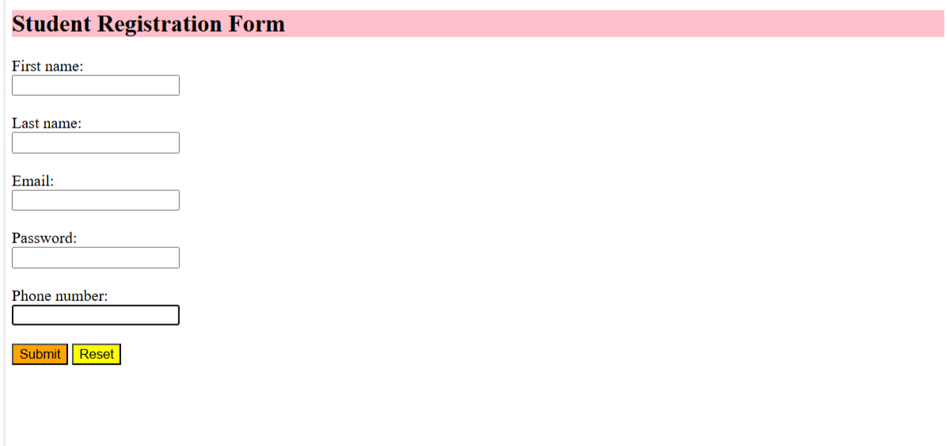
Output Analysis | The HTML web form was successfully created and displayed in the browser. It contains different input controls such as text boxes, password fields, radio buttons, checkboxes, dropdown menus, textarea, and buttons. The user can enter the required information and submit or reset the form. Thus, the objective of creating a functional web form using HTML form tags was successfully achieved.
Link of student Github profile where lab assignment has been uploaded | https://github.com/shakulvilasrathod-art/Web-technology
Conclusion | The student registration form was successfully created using basic HTML form tags. Different input elements such as text fields, email, radio buttons, date input, and submit button were used. The practical helped in understanding how HTML forms are designed.
Plag Report (Similarity index < 12%)
Date | 16-08-2026

